EXPERIMENT NO: 1  **BASIC LOGIC GATES** 23/01/2023

**AND GATE**

**A=0,B=0**

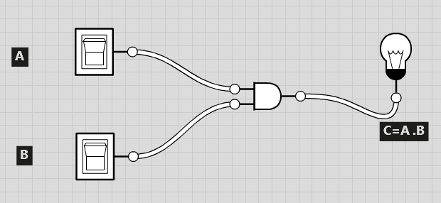

A=0,B=1

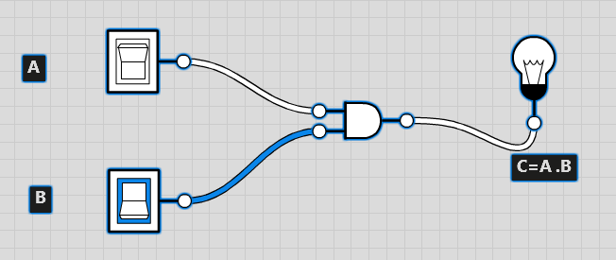

**A=1,B=0**

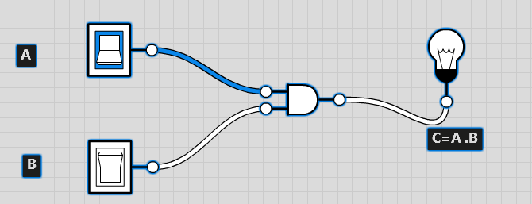

**A=1,B=1**

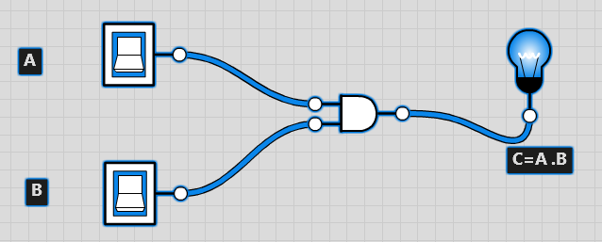

**TRUTH TABLE**

